# **Format for uploading details in GitHub and Slack in word file format**

**Student Name: Shrinivasa**

**Class and Sec: VI B**

**USN: 4AL17CS092**

|  |  |  |  |  |
| --- | --- | --- | --- | --- |
| **Online Test Details** | | | | |
| **Subject** |  | | | |
| **Semester** | **VI - B** | | **Duration** | **Minutes** |
|  | |  | | |

**Encl: snapshot of the test result**

|  |  |  |  |
| --- | --- | --- | --- |
| **Pre-Placement Training Summary** | | | |
| **Pre placement training** | **9:00 am to 11:00 am - Programming in Java**  **11:00 am to 1:00pm – Data Structures** | | |
| **Faculty** | **Ms. Shilpa**  **Mr. Venkatesh** | **Duration** | **4 hours** |

**Encl: snapshots of the daily class activities (at least two snap shot)**

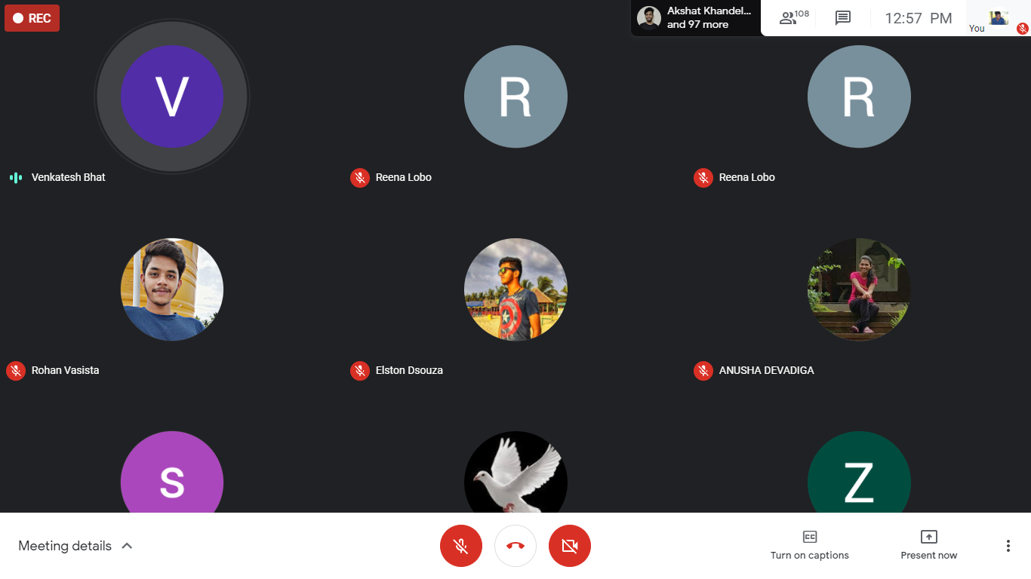

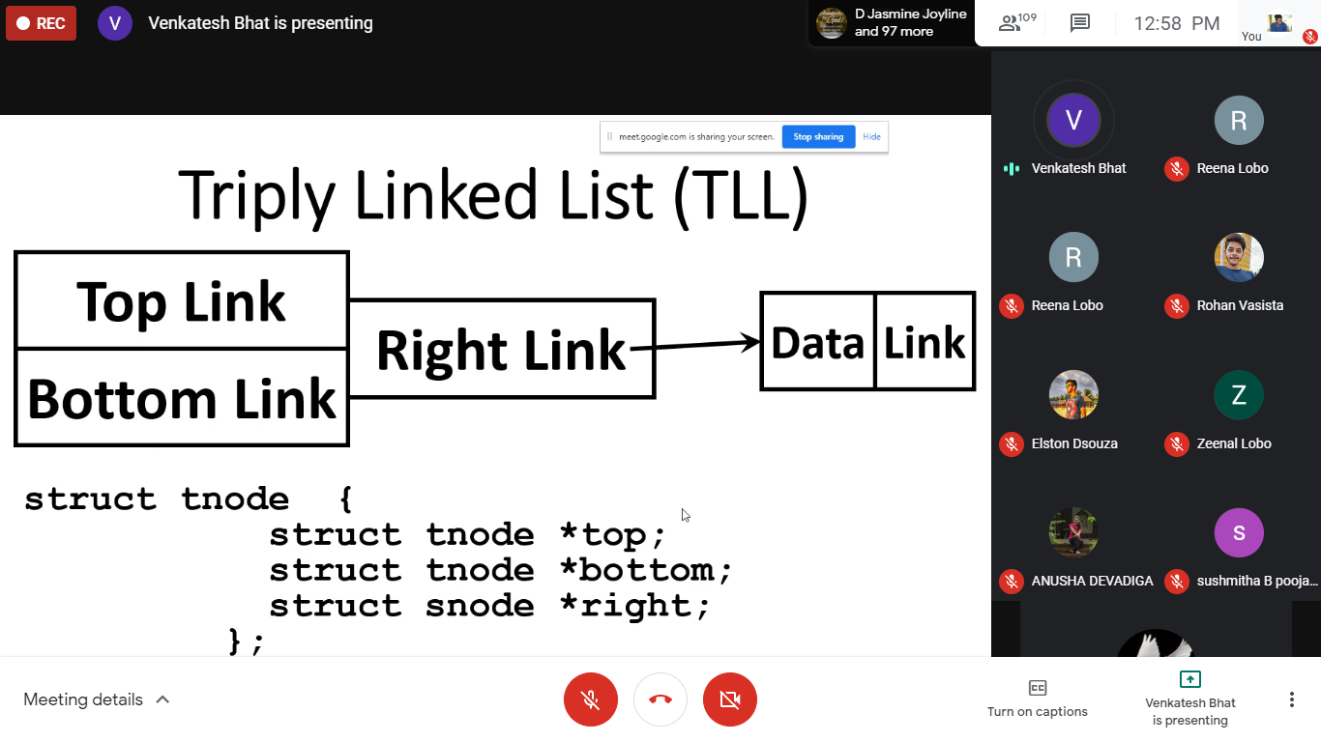

|  |  |
| --- | --- |
| **Coding Challenges** | |
| **Problem Statement: Pro1(java)**  [**https://github.com/Shrinivasakunder/certification-and-online-coding**](https://github.com/Shrinivasakunder/certification-and-online-coding) | |
| **Status: Completed** | |
| **Uploaded the report both in GitHub & Slack** | **Yes** |

**Encl: snapshots of your response to challenge.**

**Pro1(java):**

**Create a class named 'Shape' with a method to print "This is This is shape". Then create two other classes named 'Rectangle', 'Circle' inheriting the Shape class, both having a method to print "This is rectangular shape" and "This is circular shape" respectively. Create a subclass 'Square' of 'Rectangle' having a method to print "Square is a rectangle". Now call the method of 'Shape' and 'Rectangle' class by the object of 'Square' class.**

